Linda Widomski PO Box 290
NYCASE Executive Director Greenfield Center, NY 12833
E-mail: lwidomski@nycase.org Cell: 845-701-0855

Dear Vendor:
July 18-20, 2022! Save this date for your opportunity to participate in this widely acclaimed, high quality professional development event: the 2022 New York Council of Administrators of Special Education 20th Annual Summer Institute. As the Executive Director I have met many of you, or spoken to you on the phone or shared information by email regarding your participation in this important event. For the event we will be at the beautiful Embassy Suites Hotel located at the Destiny USA Mall on the shore of Onondaga Lake in Syracuse N.Y. There is an enclosed walkway from the parking lot of the hotel to the six-story shopping and entertainment complex at Destiny USA. You may access the conference rate ($149) for hotel rooms by clicking on this link: https://group.embassysuites.com/taxhms Be sure to book you room prior to June 16th to receive the conference rate.

Our conference title is:
Forward Together ~ Building Bridges

The theme for this year’s Summer Institute is Leadership and Diversity, Equity and Inclusion. You are invited you to join us for an exciting business opportunity either as a return vendor/service provider, or as a new participant at our conference. Attendees are special education administrators. leaders and practitioners who have the authority to make spending decisions. We make every effort to provide our vendors with maximum visibility and contact with conference participants. A copy of the Exhibitor Floor Plan is included with this letter.
We provided dedicated Vendor Showcase Time in our schedule for table visits. As you plan for the conference note that meals for vendors are included with most levels of sponsorship but not all. You are welcome to participate in meals if it is not included but there is a fee. Let us know if you need that information. Please be sure to review the chart that details the sponsorship levels before completing the registration form. Each there are updates and revisions. The information following explains NYCASE vendor policies, opportunities and levels of participation.
To ensure optimal exhibit location and benefits, You are encouraged to fill out the Vendor Reservation Form below as soon as possible and return it by email. If you would like to sponsor a speaker, please indicate your interest on the Form with a contact name and phone number or email address and I will contact you directly to discuss. Please be aware that the sponsorship of a speaker will include all associated costs. Do not hesitate to contact us with any further questions. Contact Information:
lwidomski@nycase.org
(C ) 845-701-0855
Linda Widomski
NYCASE Executive Director
PO Box 290
Greenfield Center, NY 12833
We thank you for your support and look forward to working with you.
Best regards,
Linda

Vendor Showcase Schedule
(Times are subject to change and may vary slightly depending upon presenter needs)

Sunday, July 17, 2022
Open for Vendor Set-up: 3:30pm-5:00pm
Monday, July 18, 2022
Open for Vendor Set-up: 7:00 AM – 9:00 AM
Vendor Hours: 7:45 AM – 5:00 PM
Tuesday July 19, 2022
Vendor Hours: 7:45 AM – 4:00 PM
Wednesday July 20, 2022
Vendor Hours 7:45 Am – 11:30 AM

** Please note – We host a raffle of Vendor donated items each year on Wednesday. We encourage vendors to bring an item to the conference as it increases attendee participation and table visitation. The Raffle is very popular with attendees and to qualify for the drawing, participants must get their Vendor Raffle cards initialed by each vendor, thus increasing your contacts!!
It is helpful if we know before the conference regarding the raffle items you will be donating.

**please note that Vendors may choose the days they wish to participate. Please complete this information
on the form that follows.

Vendor Gallery Floor Plan ** subject to change

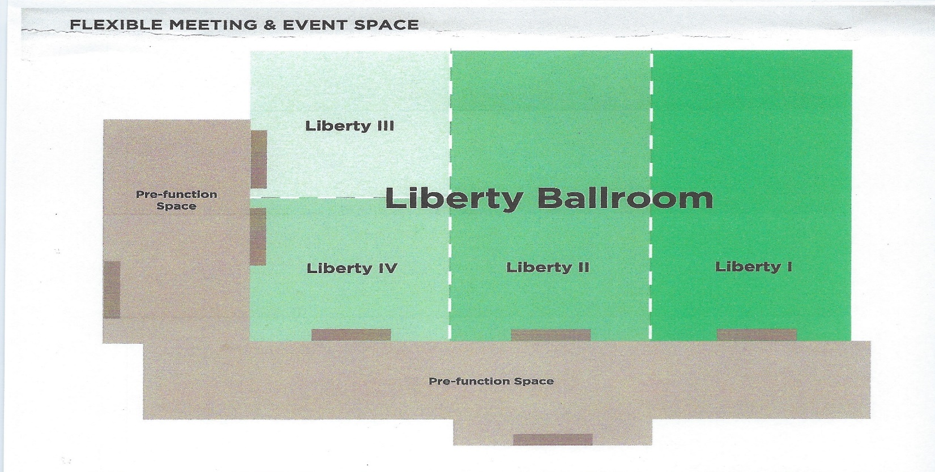

Vendor Responsibilities
Vendors must contact NYCASE in advance for any special requests or custom needs to arrange displays. Additional fees may be charged depending on the need.
- Vendors are responsible for bringing the necessary extension cords required to operate electrical devices. There are a limited number of outlets. You will need to contact Danielle Neuser Hotel Event Manager at Danielle.Neuser@hilton.com for those arrangements.
- All electrical devices must conform to fire codes of the Embassy Suites Hotel.
- Displays must not obstruct the view of, nor interfere with traffic to other exhibits or speaker presentations. Exhibits that exceed the allotted space, will incur an additional table fee of $150.
- No part of the exhibit may be pasted, nailed, taped, glued, tacked, stapled or otherwise attached to walls, doors, etc.
- Demonstrations, interviews, and distribution of materials must take place at the exhibitor’s table, unless specific arrangements are made in advance with NYCASE, and must not infringe upon the privileges of other exhibitors. Volume must be at a level that does not intrude on other exhibitors’ conversations, presentations or adjacent speaker activity.
- NYCASE reserves the right to approve the character of the exhibits and the right to refuse exhibit displays or materials.
- Exhibits may not be set up earlier than 5:00 pm on Sunday, July 17, 2022. There are also opportunities for set up on Monday morning. Tables will be in the pre-function space and assigned to each vendor/exhibitor by NYCASE.
- Exhibitors sending boxes by mail should not do so more than 5 days prior to the event. Mail boxes to the hotel noting NYCASE Summer Institute in the address if you are not staying at the hotel. If you are a guest of the hotel you may use your name and the hotel address. If you have questions reach out to the sales office or Danielle Neuser.
- Vendors must dismantle and remove all materials by 1:00 PM, Wednesday July 20, 2022.
- If you require special accommodations due to medical or physical needs, please notify the NYCASE Executive Director.
- Parking spaces for vendors are located in the hotel parking lot. There are no parking fees.
- Vendors are asked not to schedule a social event Monday prior to 5:30pm as NYCASE holds its President’s Reception that afternoon (4:00-5:30pm). If there are any questions please contact the NYCASE Director at (845)-701-0855 or email lwidomski@nycase.org

Payment Agreement
NYCASE guarantees exhibit space and/or sponsorship as soon as payment is received. Payment is to be made by check or money order made payable to NYCASE and mailed to NYCASE, PO Box 290, Greenfield Center, NY 12833. Payment should be sent prior to the Summer Institute Conference.

Cancellation Policy
NYCASE requires written notice of vendor cancellation. NYCASE provides no refund for cancellations
made after May 1, 2022. NYCASE will provide a 25% refund if the cancellation occurs between April 1 -
April 31, 2021. NYCASE will provide a 50% refund if the cancellation occurs before April 1, 2021
If in the event a vendor does not notify NYCASE that he/she is unable to attend the conference and/or does not
appear at the conference site to set up, there is no refund.
Liability Policy
The vendor’s property is displayed at his/her own risk. Neither the conference site, its representatives, nor
NYCASE shall assume any responsibility thereof. The exhibitor shall assume all responsibility for any
loss incurred due to accident, fire, theft, flood, lightning or other circumstance beyond the control of
the conference site management and NYCASE. All exhibitors shall assume full liability and shall hold the
conference site and NYCASE harmless from any and all claims arising from any act of omission on the
part of the vendor, his employees or agents.
Compliance with Laws
Exhibitors shall comply at all times with all federal, state, and local laws, including the rules of the venue.
Non-Assignment
This agreement, or any part thereof, may not be assigned or transferred.
Disclaimer
NYCASE makes no guarantees, opinions or promises, expressed, or implied, regarding the number of people who will attend the event, the amount of revenue the exhibitor may expect to generate from the event, or any other matters regarding the event.

Hotel Accommodations
Embassy Suites Syracuse at Destiny USA by Hilton
311 Hiawatha Blvd W Syracuse, NY 13204

Hotel Information
Please visit the Embassy Suites Hotel website at www.syracusedestinyusa.embassysuitesbyhilton.com
The hotel is located not far from the Syracuse Hancock International Airport https://syrairport.org/ and the Amtrak station https://www.amtrak.com/stations/syr
Vendors are responsible for their own accommodations. You are invited to take advantage of our
NYCASE association special room rate as noted below and as long as you make your reservations prior to close of business on June 16, 2022

$149/night Standard Room
Please Note: In order to secure a hotel reservation, you must use the booking
https://group.embassysuites.com/taxhms or call the hotel directly at 315-313-1650 and reference
NYCASE.

If you have any problems with conference rate for your hotel reservation, please contact the NYCASE Executive Director by phone: 845-701-0855, or by email: lwidomski@nycase.org

Please be aware that if you select Platinum or Gold level Sponsorship, we must have your company link/advertisement on or before June 1, 2022 in order to place it on the Mobile App. Also, please know that the Embassy Suites Hotel has free wireless internet access available in their conference rooms; however, should you require a dedicated internet access line, there will be an additional charge.

We are looking forward to your participation in what we know will be an outstanding Summer Conference and opportunity for you. Please indicate your interest by completing the following Vendor Form and e-mail it to me at lwidomski@nycase.org . Please know that early registration will ensure a vendor space. Please make business checks, personal checks or purchase orders payable to NYCASE and mail directly to

NYCASE
PO Box 290
Greenfield Center, NY 12833

See form on next page

2022 20th Annual Summer Institute Vendor Reservation Form
July 18-20, 2022

Company Name: _____
Contact Person(s): ________________________________________ _
Vendor Attendees: _ ___ Title Title
____
Address: _
___________________________________________
Telephone: ____________________
Fax: E-mail:

Level of Participation:
I would like to sponsor a speaker (which will include all associated Costs including travel) and in addition to the Conference/Exhibitor Sponsor Fee
Name: email/phone

Conference Sponsor/Exhibitor Fee
Platinum: Co-Sponsor/or Presidents’ Reception Sponsor $5000+ ____________ (note here amount)
Gold: Meal Sponsor $3000
Silver: Association Sponsor $2000
Bronze $1500
Patron level I $1000
Patron level II $ 500
Add On – Coffee Break Sponsor $725-$1450 (half/full day)
Add On – Snack Sponsor $650
**Dates of Participation:
Please check the dates you will be participating as a vendor in the conference.
Sunday July 17th Set Up ____ Monday July 18th _____ Tuesday July 19th ____ Wednesday July 20th ______

Vendor Needs:
- Additional six foot table(s) ($150 each): additional requested: (enter # requested) _______
- Breakfast for your staff who are not covered within your level of participation: $18.00 per meal
Indicate Number: Tues July 19th : ___ Wed. July 20th ______

- Lunch for your staff who are not included within your level of participation: $25.00 per meal
Indicate Number: Mon July 18th : ____ Tues July 19th:_____

Please Note: Meals are only included for the following participant levels:

Platinum (all members) Gold (3 staff members) Silver (2 staff members)
$5000 $3000 $2000
Bronze (2 staff members) Patron I (1 staff member)
$1500 $1000

Donations for the Raffle

Yes, I would like to donate my company’s products or services for the NYCASE Summer Institute raffle.

I plan to ship my donations to the venue site.

I plan to bring my donations to the conference venue.
To help us plan, please briefly describe your donation:
____________________________________________________________________________________

Important Notice

You must submit this signed agreement when you submit your reservation. Note: if you are submitting an online Vendor Reservation Form, you must send this signature page with your payment, or separately.

I* AGREE TO THE TERMS AND CONDITIONS AS
Name of company representative
OUTLINED ON THIS NYCASE 2021 SUMMER INSTITUTE VENDOR INFORMATION AND REGISTRATION FORM. (*SIGNATURE REQUIRED)

Please return form (or signature page if submitting online form)) with payment on or before June 1, 2022. Please make checks or purchase orders payable to NYCASE and mail directly to:

NYCASE
PO Box 290
Greenfield Center, NY 12833

New York Council of Administrators of Special Education
Summer Institute Sponsorship Opportunities
Benefits | $5000+  Platinum  Sponsor | $3000  Gold  Sponsor | $2000  Silver  Sponsor | $1500  Bronze  Sponsor | $1000  Patron I | $500  Patron II | Add on Option  Coffee Break or Snack Sponsor  Coffee Full/Half Day $1450/$725  Snack $650
Advertised on digital signage & Mobile App as Platinum or Presidents' Reception Sponsor
Introduction & Recognition at Presidents' Reception
Advertised as NYCASE Conference Co-Sponsor: | Co-Sponsor | Lunch Sponsor | Breakfast Sponsor |  |  |  | Coffee Break Sponsor
Introduction to full audience with the opportunity for 5 a minute talk | During Welcoming Address | During Meal | Announced at a Keynote
Complimentary Conference Attendance | 5 | 3 | 1
6- Foot Exhibit table, chairs, wastebasket & wireless connection
(some table locations may require extension cord or electrical line requested from venue)
Preferred Table Location | First Choice | Preferred
Company name and or logo on digital signage
Participant List
Complimentary link to website or ad
on Mobile App
Company or Association name, Logo, website address, & contact info included on Mobile App
Website Link on NYCASE Website
Early Table set up available on 7/17 | 5:00pm | 5:00pm | 5:00pm
Complimentary meals for vendors | All reps | 3 reps | 2 reps | 2 reps | 1 rep
3/3/22

