I 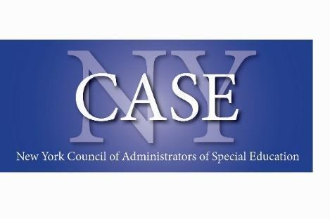

**PD Committee Agenda**

June 17, 2025

1. Reviewed May Meeting [Notes](https://docs.google.com/document/d/1ECfJKC9gKn2GZI1XcLjDDiaOyD5cOxSz/edit)
2. Reviewed Conference Plans - [Summer Institute - Year-at-a-Glance](https://docs.google.com/document/u/0/d/15UnryQzQQDGG4KT6bmfNZeu_2dbofOzkjv2prbO_AaQ/edit)

We are on schedule! Cat and Selena will review the Guidebook when it is ready to be published.

1. Conference Schedule Review - [Schedule](https://docs.google.com/document/d/1DTtmEAl7hiYJDvRettl0dMo8Ueu63EPv/edit) Nearly complete. Waiting for Diamond Sponsors to send their session information.
2. Review Vendor Registration  [List](https://docs.google.com/document/d/1sTj9v2GECXkFvJ5dzjxGBsl8PagTLtwU/edit) Going strong. At 30 tables!
3. Discuss Attendee Registration [Tracker](https://docs.google.com/spreadsheets/d/1L6mz7Tds2BQnlQH_nJpWiS5LD7pe8WuSpC6BUpGSBqQ/edit?gid=0#gid=0) We met our goal and are now over 106!
4. Slideshow - [Slides](https://docs.google.com/presentation/d/1BrDQ1QQBnI4iCGzuYS8l7wGva_nSdkN-9M4uluicFdg/edit?slide=id.g2ec788f0bcb_0_0#slide=id.g2ec788f0bcb_0_0) It was suggested we add a thank you to the PD Committee!
5. Hotel Update - Fully Booked!

Thank you to the Committee!!